Name: Arpit Mahalle
Day 21 Daily coding assignment output screenshots

Challenge 1:
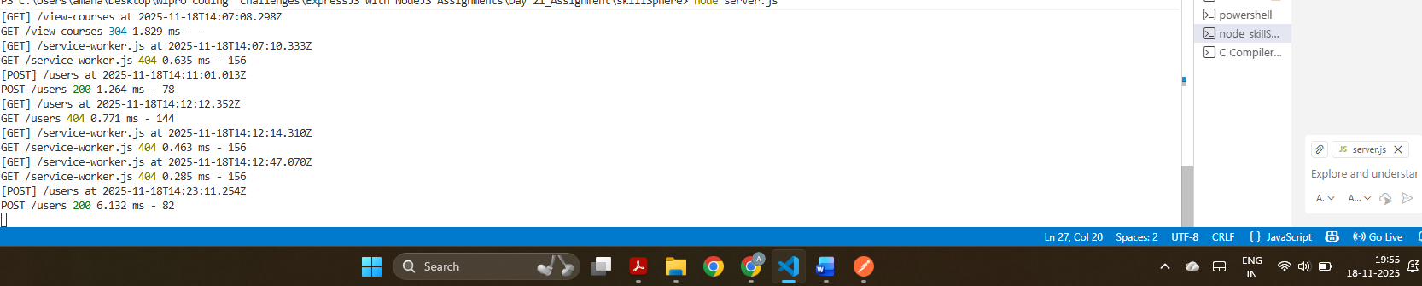
The terminal shows logs of incoming requests with the timestamps. The logging middleware is working as it shows the desired output.

Challenge 2:
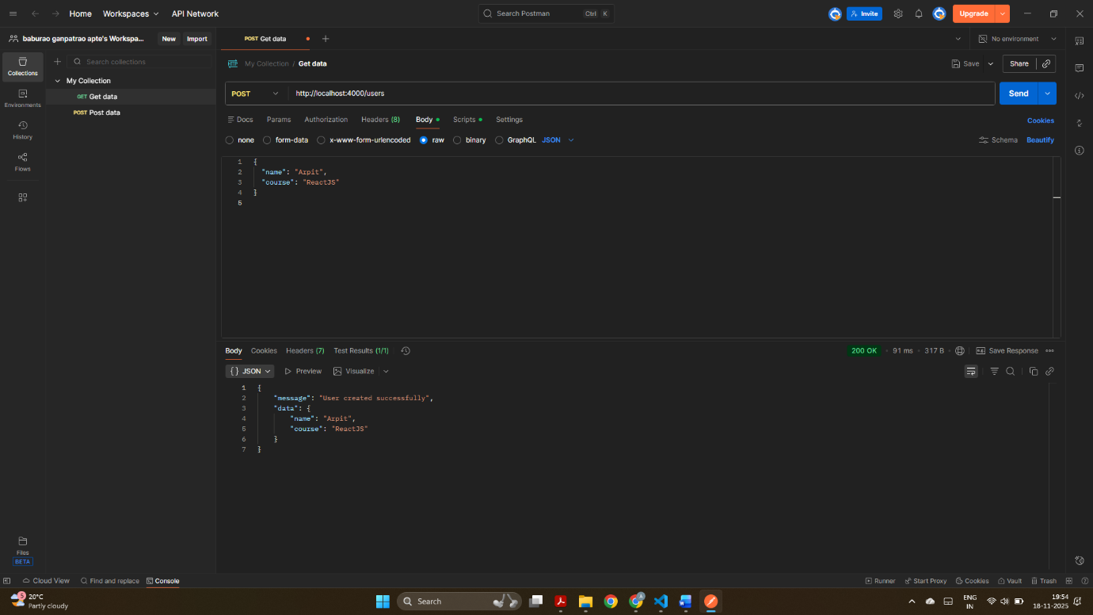
This screenshot shows a POST request sent to /users page with JSON data for new user. The server responds with a success message i.e “User created successfully”. This confirms that built-in middleware(express.json & express.urlencoded) processed the request correctly.

Challenge 3:
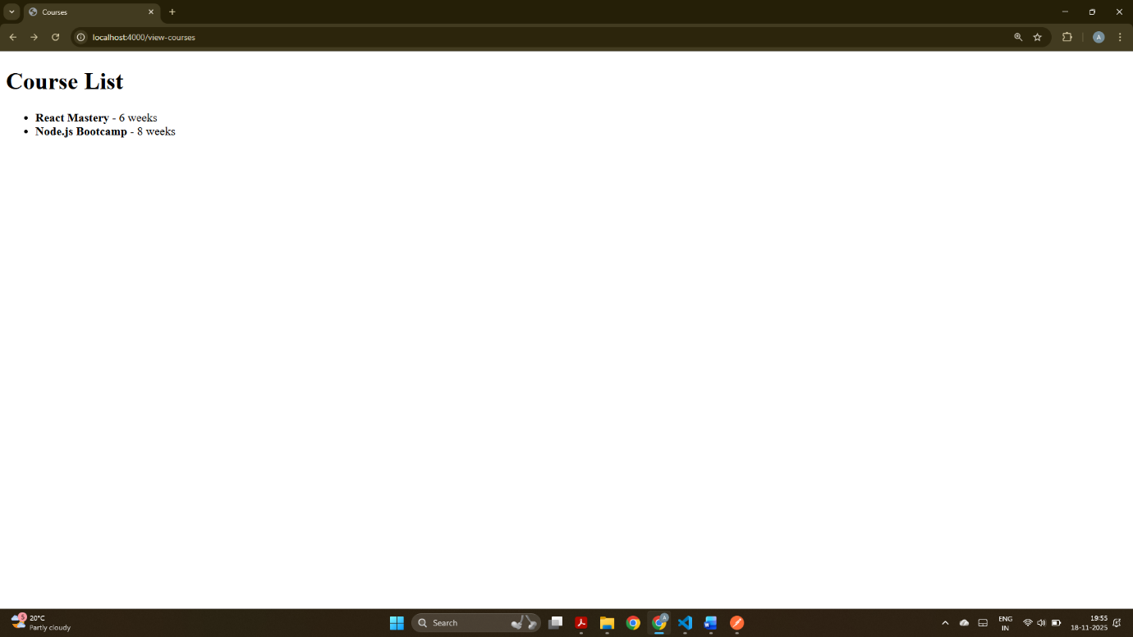
The view-courses page shows the EJS template and displays the list of available courses in a HTML list. So, this outcome confirms that the template engine and dynamic rendering are working correctly.

